Exercise: Basics of Multi Threading

1) Create and Run a Thread using Runnable Interface and Thread class and show usage of sleep and join methods in the created threads.

Answer:

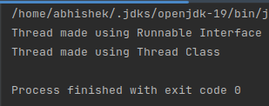

2) Use a singleThreadExecutor, newCachedThreadPool() and newFixedThreadPool() to submit a list of tasks and wait for completion of all tasks.

Answer:

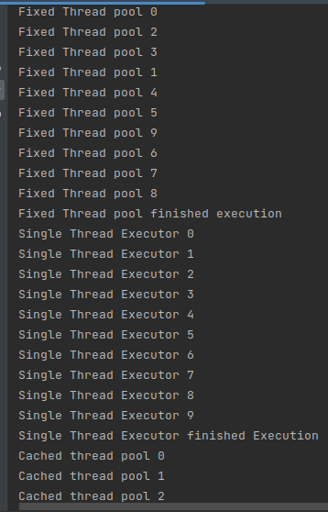

3) Use Synchronize method and synchronize block to enable synchronization between multiple threads trying to access method at same time.

Answer:

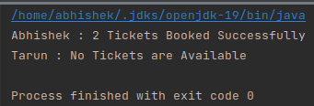

Synchronized Block

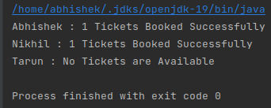

Synchronized Method

4) WAP to show usage of Callable and demonstrate how it is different from Runnable

Answer:

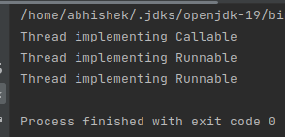

5) Write a program to simulate a deadlock in java and then improve the program to handle the deadlock using reentract lock.

Answer:

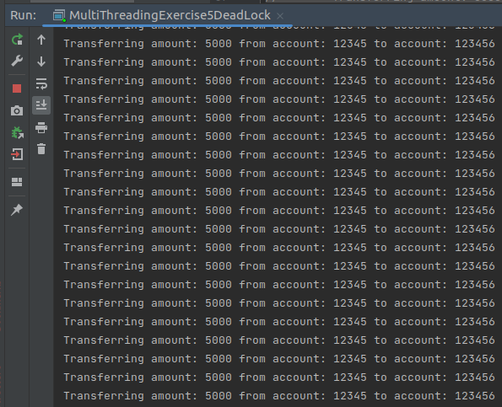

Deadlock

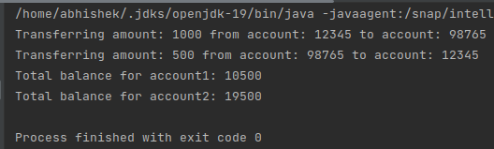

Deadlock Resolved using Reentrant Lock